Chapter 3, Solution 48

We apply mesh analysis and let the mesh currents be in mA.
3k

I₄

4k 2k 5k

I_{o}
1k I₃ -
I₁ I₂ 3 V
+ +
6 V + 10k
- 4 V
-

For mesh 1,
(1)
For mesh 2,
(2)
For mesh 3,
(3)
For mesh 4,
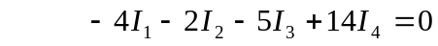 (4)
Putting (1) to (4) in matrix form gives
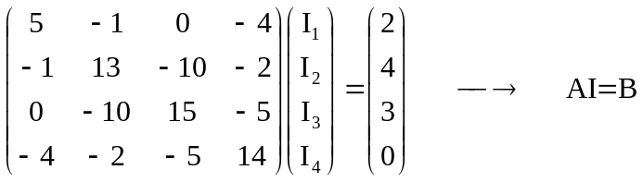
Using MATLAB,

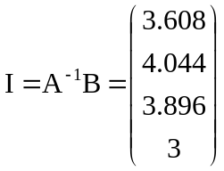 0.148
The current through the 10k resistor is I_{o}= I₂ – I₃ = 148 mA.

